**HumanIK Setup**

**3DS Max**

**Skeleton Setup**

IK Effectors should be added to the skeleton and parented to the **Root/Main** bone. These bones should be set to “Use Translation”.

* Root/Main
  + Hips/Pelvis
    - Everything Else
  + **IK_FrontLeft**
  + **IK_FrontRight**
  + **IK_BackLeft**
  + **IK_BackRight**

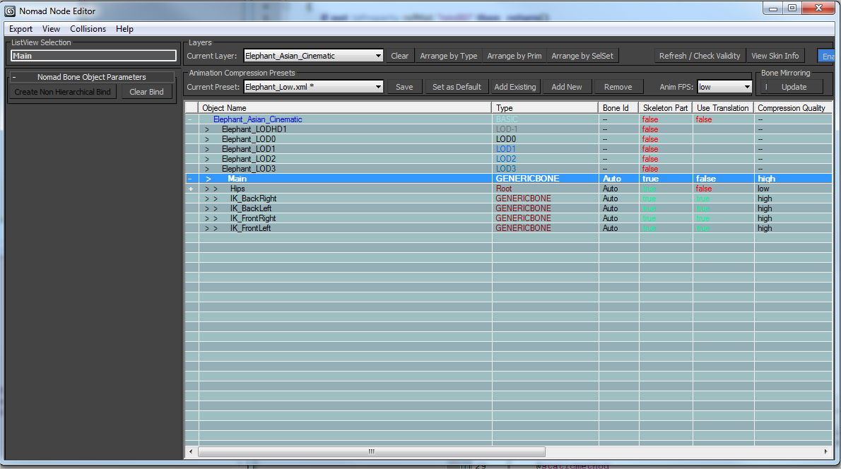

The IK effectors should be placed at the **bottom of the feet**.

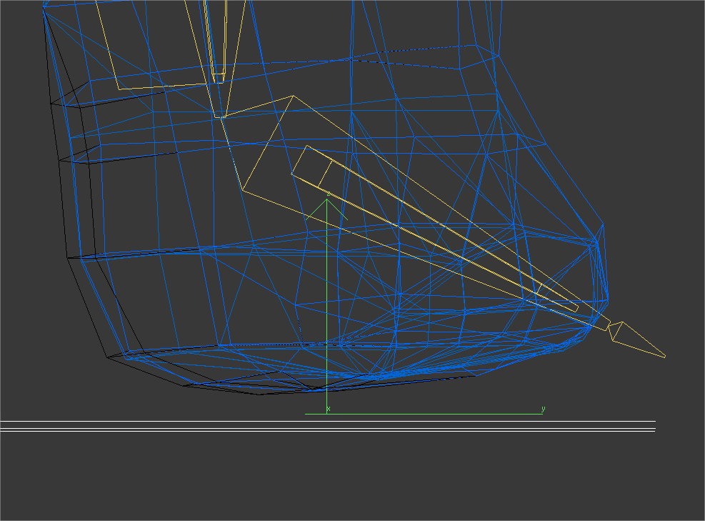

**IMPORTANT NOTE:**  
One major change with the skeleton setup for IK is that the **Main** bone is now part of the skeleton. The **Hips** were historically the root of the hierarchy. With the Main bone as the Root of the hierarchy, the IK effectors can be animated relative to the character’s space, rather than being counter-animated from the Hips which typically aren’t stable.

When exporting from the Nomad Node Editor, the skeleton file is named after the top bone of the hierarchy. This means that the XML file has to be manually renamed from **Main_ref.skel.xml** to **Hips_ref.skel.xml**since Hips_ref.skel.xml is what’s used by the archetypes in Dunia.

**Rename:Main_ref.skel.xml** >>>> **Hips_ref.skel.xml**



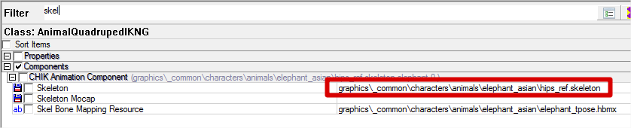

**MotionBuilder Animation Rig Setup**

**Foot Effectors**

Effectors should be **parent-constrained to the foot bones**.

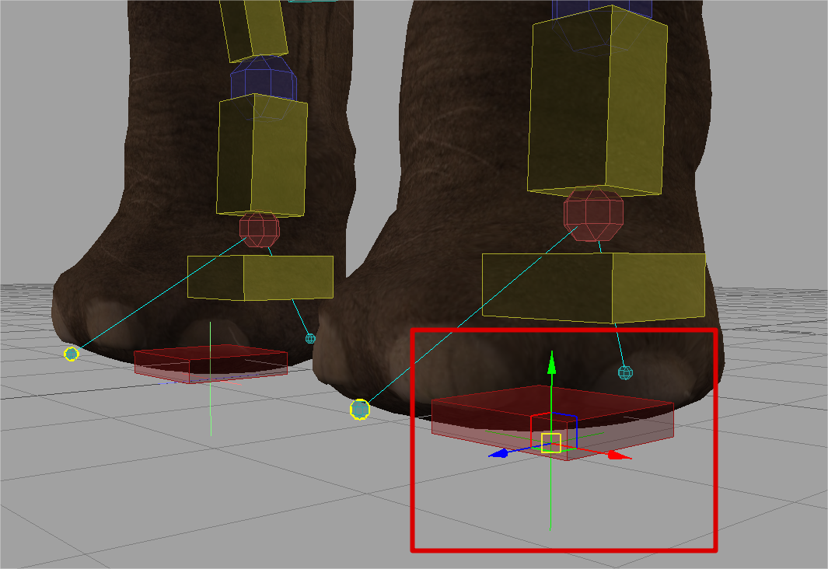

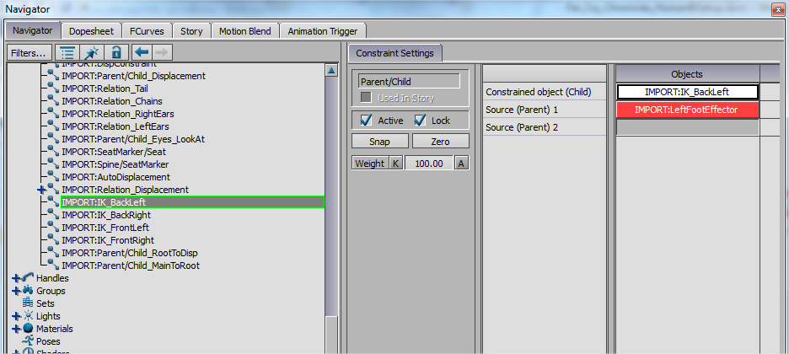

This way, the foot effectors follow the path of the feet.

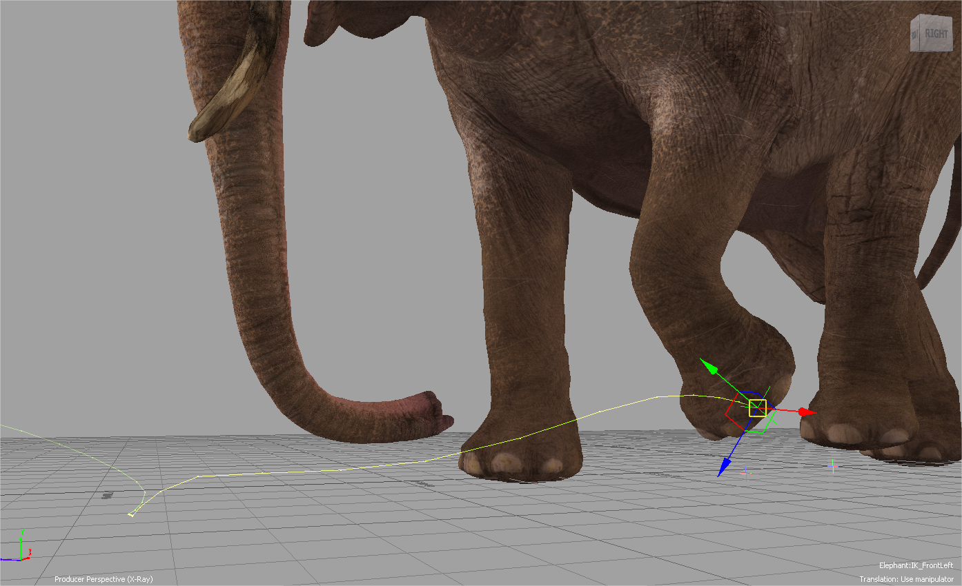

The engine can use this data to determine when the feet should be touching the ground and to set thresholds for foot locking.

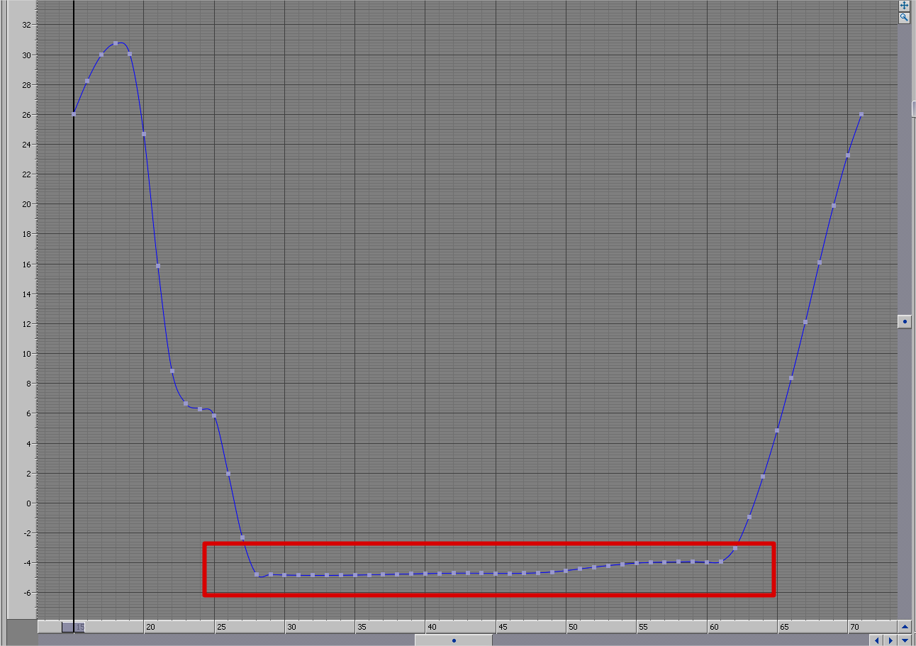

**Main / Displacement Constraint**

Make sure the Main / Root skeleton bone is constrained to the Displacement Control. **This is very important!**

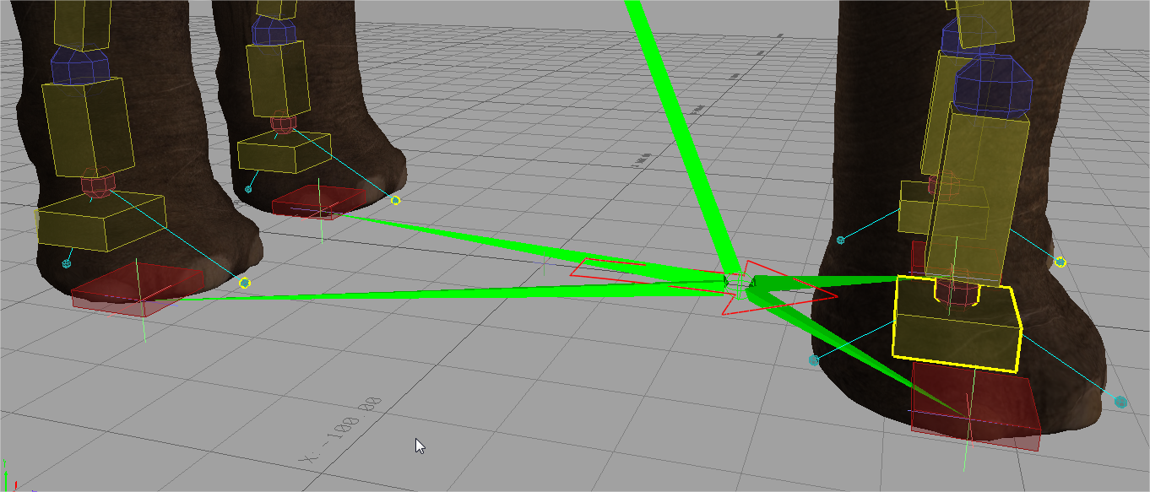

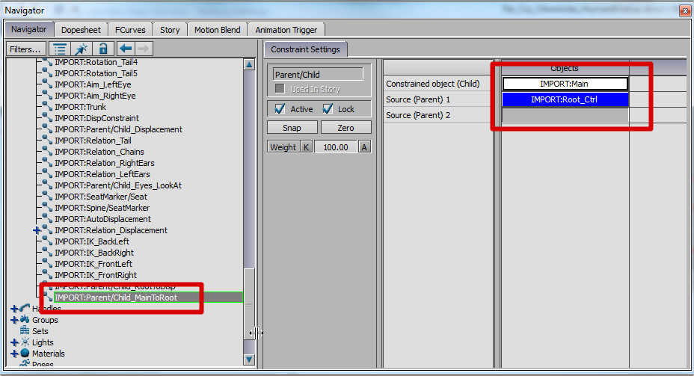

**MotionBuilder HumanIK Rig Setup**

In order for the HumanIK to be properly initialized, the character must posed and characterized in a T-Pose.

1. Start from the animal’s rig file. Save a new version of the file called **<CharacterName>_HumanIK.fbx**in the same path as the character’s Max file.
   * For example: R:\fcc\main\fcc-data-source\graphics\_Common\Characters\Animals\Elephant_Asian
2. Remove all constraints from the file. This will make it much easier to manipulate the character.
3. Remove the control rig from the file.
4. Select the character and set the Input Type to **Stance Input** and check**Active**.

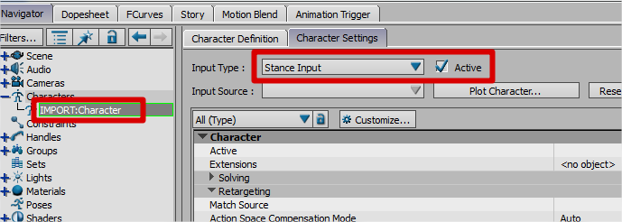

* On the character’s **Character Definition Tab**, uncheck **Characterize**.

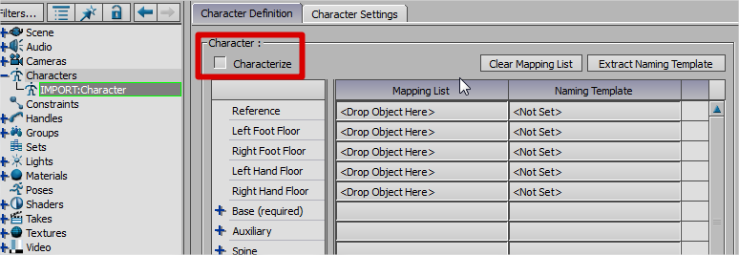

* Re-pose the character into a T-Pose using FK on the skeleton.

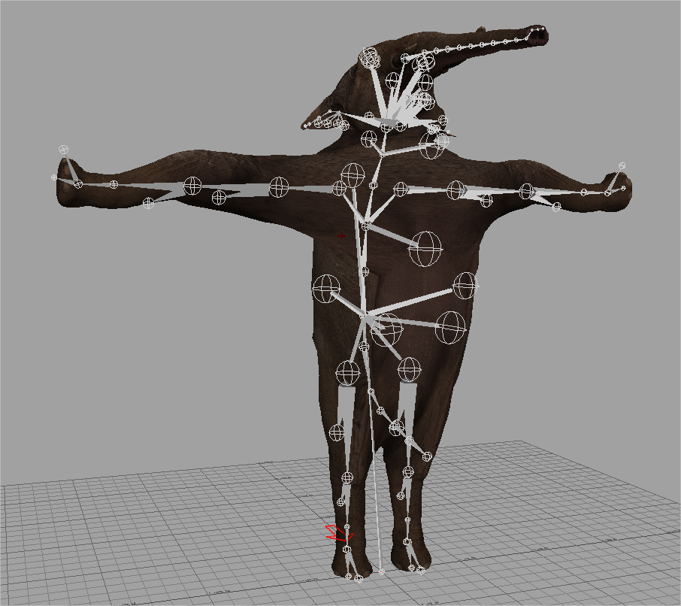

* Try to keep all the limbs straight without any twist.

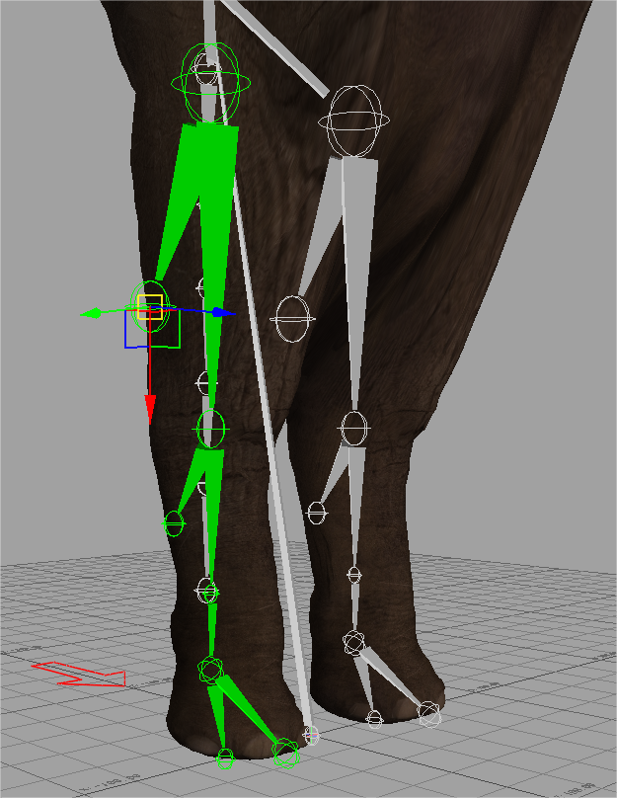

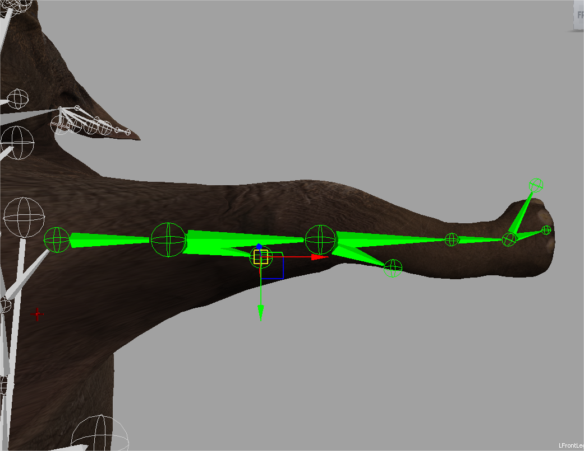

* Try to keep the hips and spine upright.

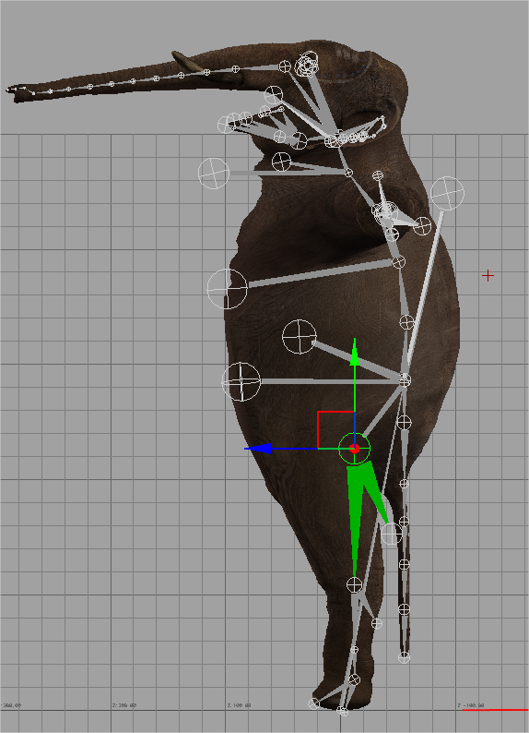

* Once completed, **re-characterize** the character. **Save the FBX file**.

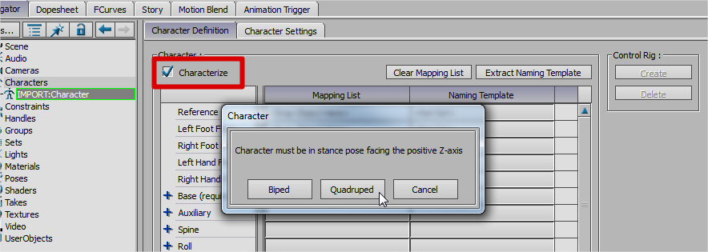

**NOTE**: Depending on the leg structure of the animal, you may have to experiment with the bones to use for the ToeBase and FingerBase. In general, these should match the bone that the IK effectors were meant to match.

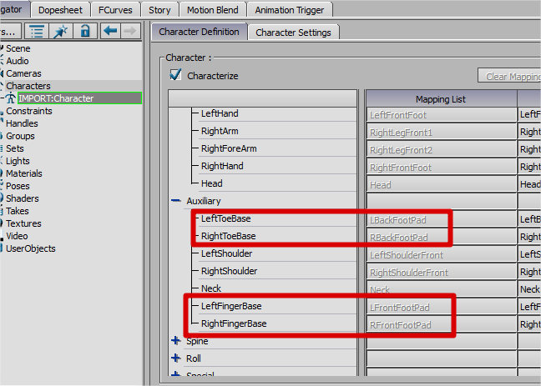

**Exporting the HumanIK Definition**

* Launch the **HumanIK Standalone Characterization Tool.**
* Load the character`s HumanIK FBX file.

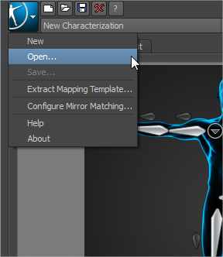

* Review the characterization to ensure the required slots are filled.

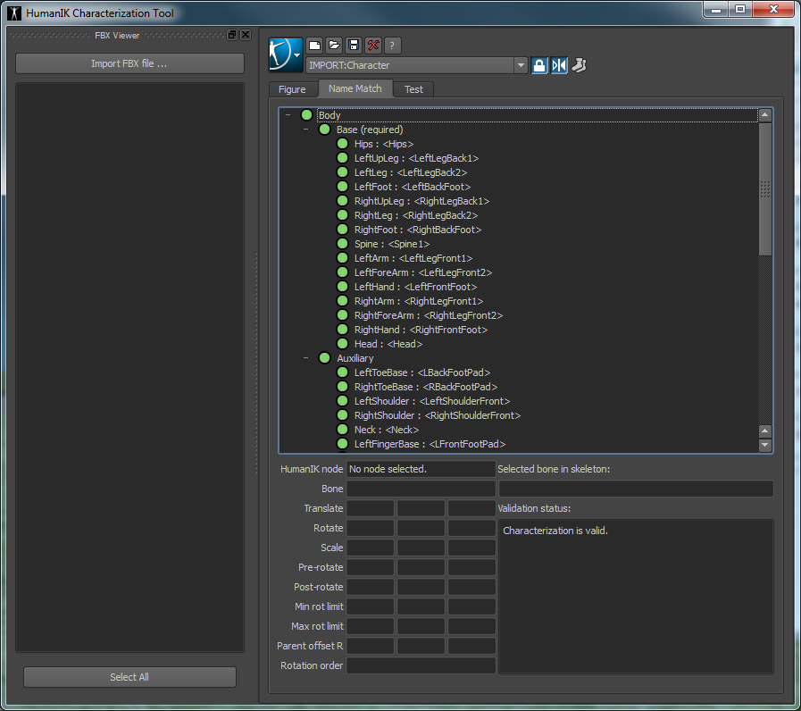

* The Test Tab can be used to preview the retargeting from various animations.

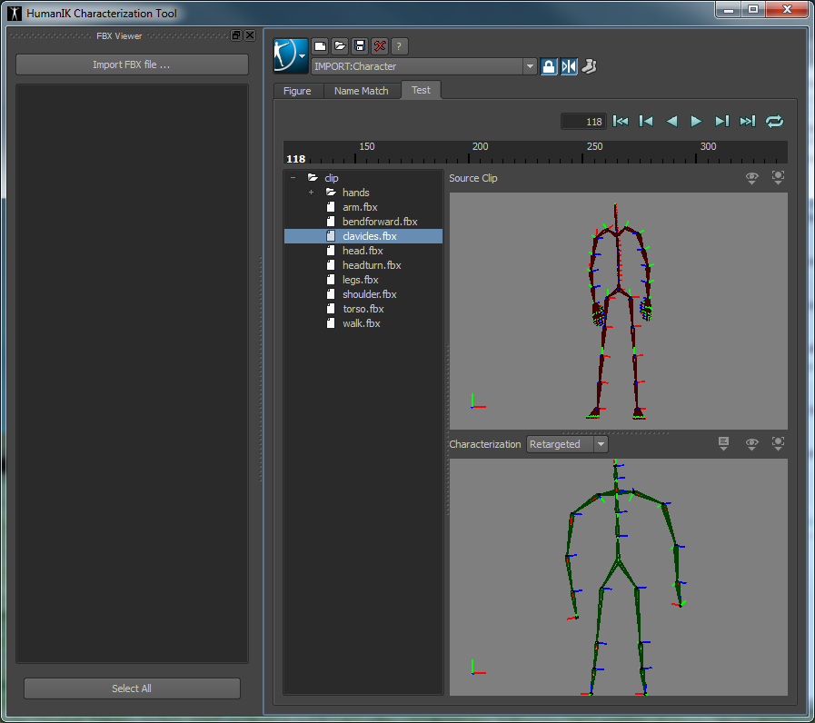

* Save the file in the same directory as the character’s exported model. (ie R:\fcc\main\data\graphics\_Common\Characters\Animals\Elephant_Asian)

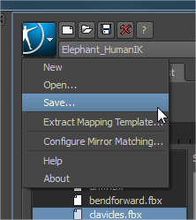

**IMPORTANT:**The saved file will need to be converted to a game-ready format.

* The file type should be set to:         **Binary HIK little endian (*.hikc).**
* Use the naming convention:         **<CharacterName>_HumanIK.hikc**.

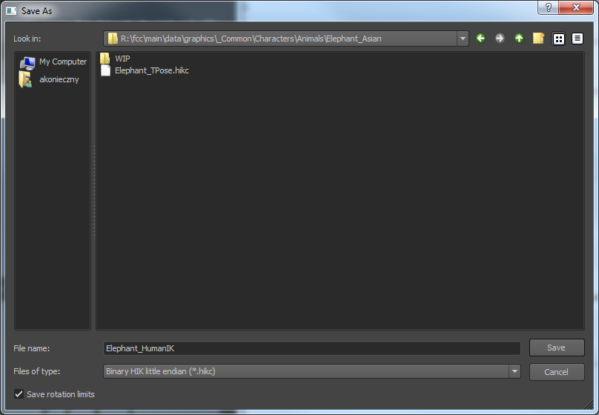

* Upon saving there will be two files. Be sure to add these to Perforce, as they will be used by the character’s archetype.

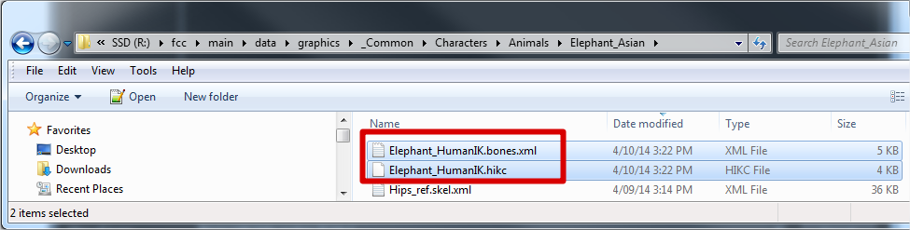

**HumanIK Setup in Dunia**

After creating the T-posed animal rig and exporting the HIK files, there will be two files, the **Characterization file (.hikc)** and the**Bone Mapping File (.bones.xml).**

* Find the character’s CHIK Animation Component within the archetype. Add the files accordingly:
  + Characterization Resource         > .hikc file
  + Skel Bone Mapping Resource     > .bones.xml file

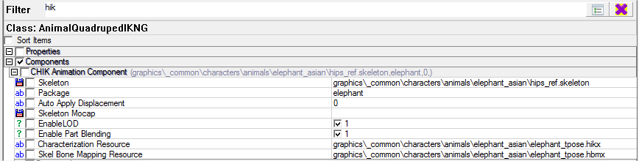

* Find the character’s QuadrupedIK Ground Follow Component. For the **Effector** fields for each limb enter the bone names for the IK effectors. These should match the bone names that were added to the Max file.

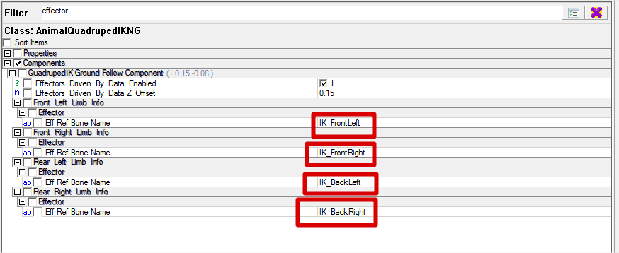

**Additive Animation Setup**

Additive animations are applied on top of the animal’s existing animations to offset the animal’s current pose based on the normal of the terrain.

* There are two animations required for this:
  + **Additive Pitch Animation**
  + **Additive Roll Animation**

The animations should just represent the animal pitched down, flat, and up and rolled left, flat, and right. The **flat-ground pose should be used as the reference pose** for the additive animations, which means there is no offset in the animations when the animal is on flat ground.

**Additive Pitch Animation**

Frame 0 (-30 degrees down)

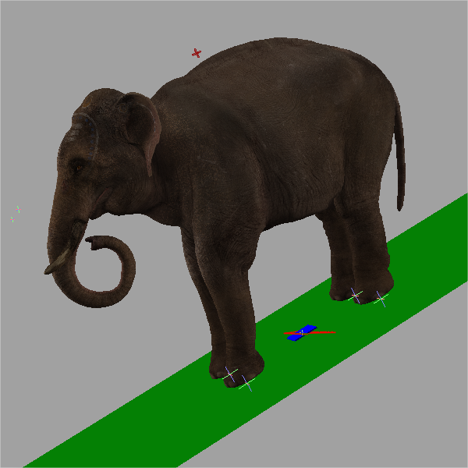

Frame 15 (flat) Reference Pose

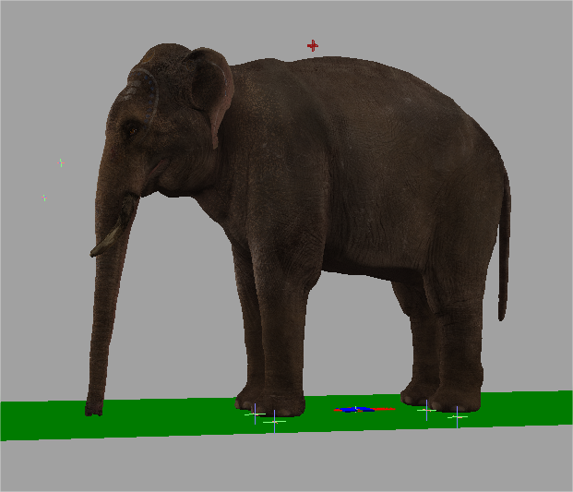

Frame 30 (30 degrees up)

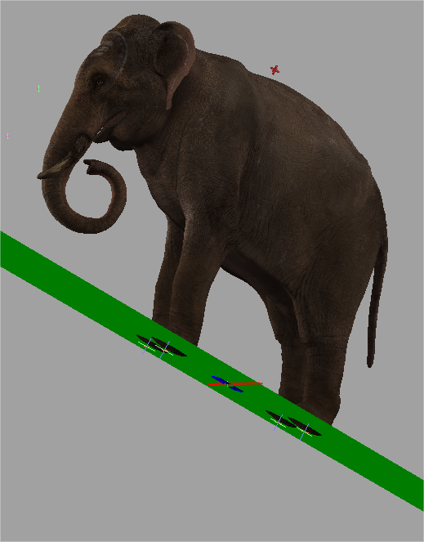

**Additive Roll Animation**

Frame 0 (-30 degrees)

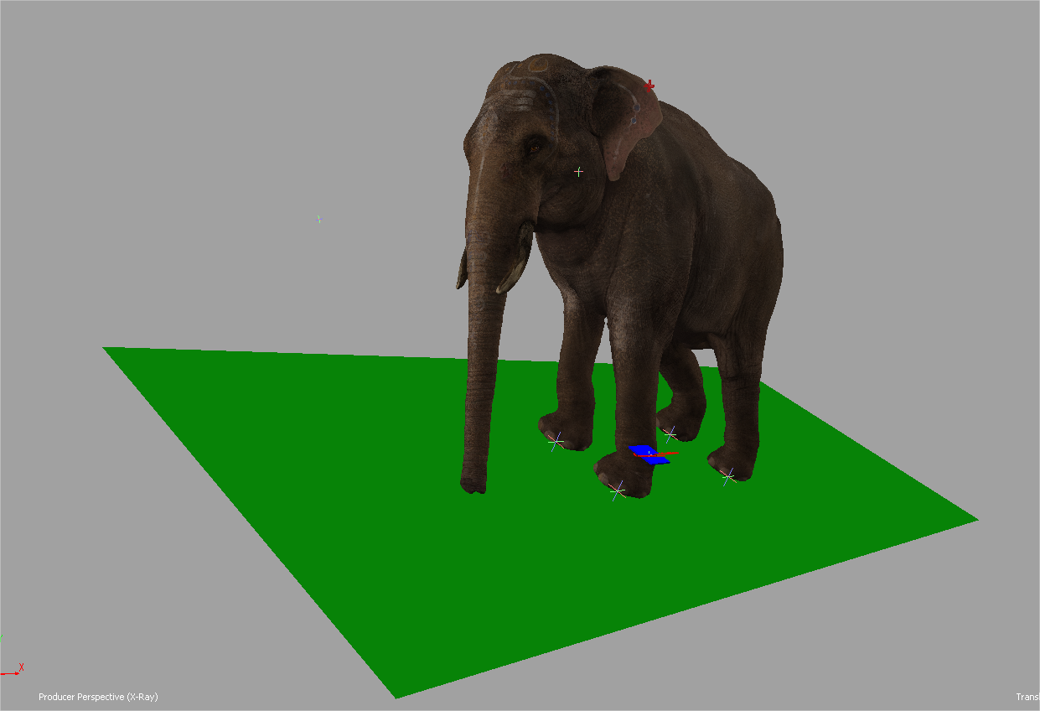

Frame 15 (flat) Reference Pose

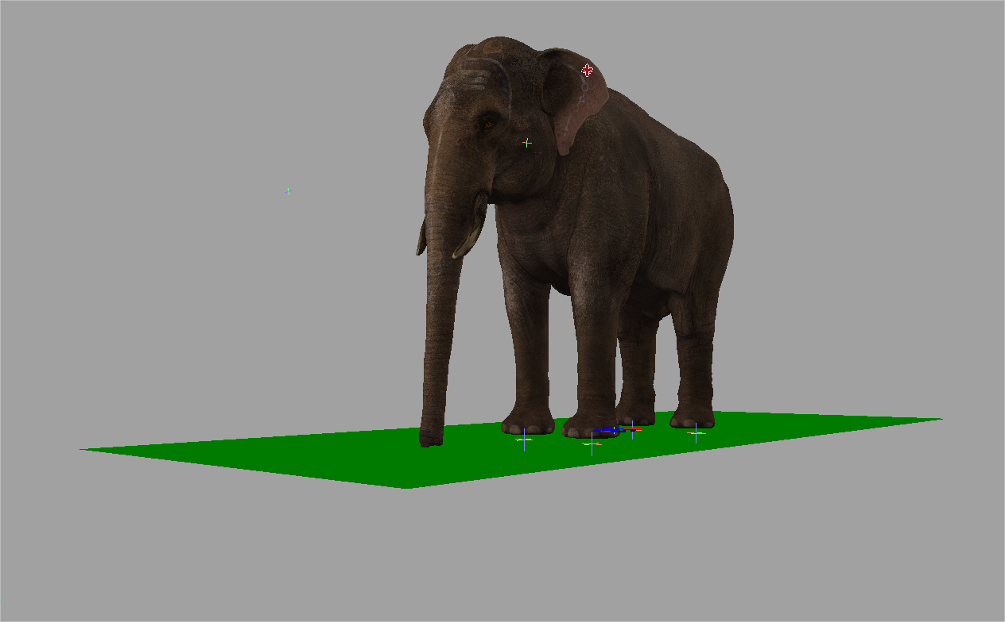

Frame 30 (30 degrees)

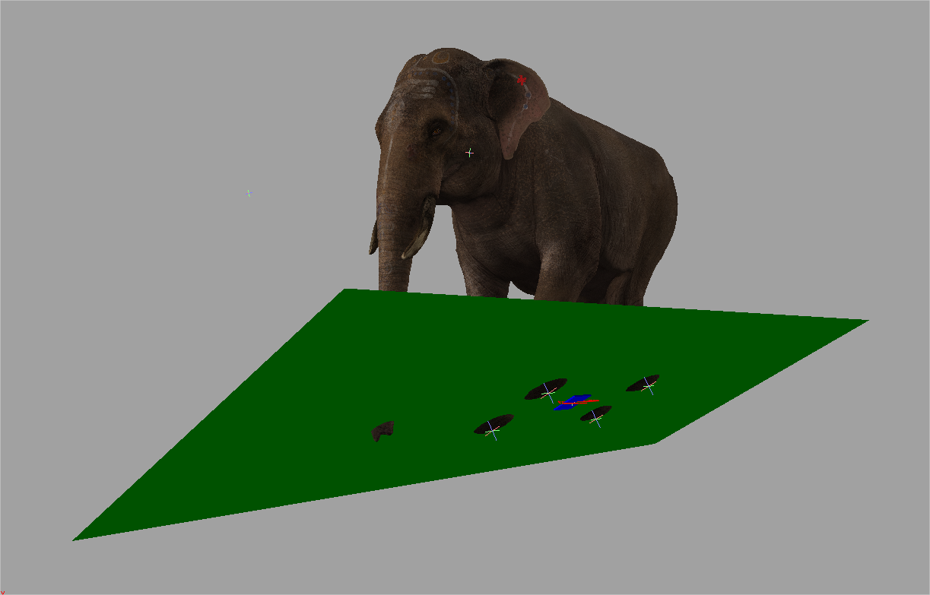

**Animation Integration in the Move**

**Additive Setup**

Find the **Add_Slope_Pitch**move and add a time-controlled animation as ADDITIVE. Set the following:

* **TimeSource     GroundPitchAngle**
* **TimeSourceMax     30**
* **TimeSourceMin    -30**

These should match the angles of the animations that were created.

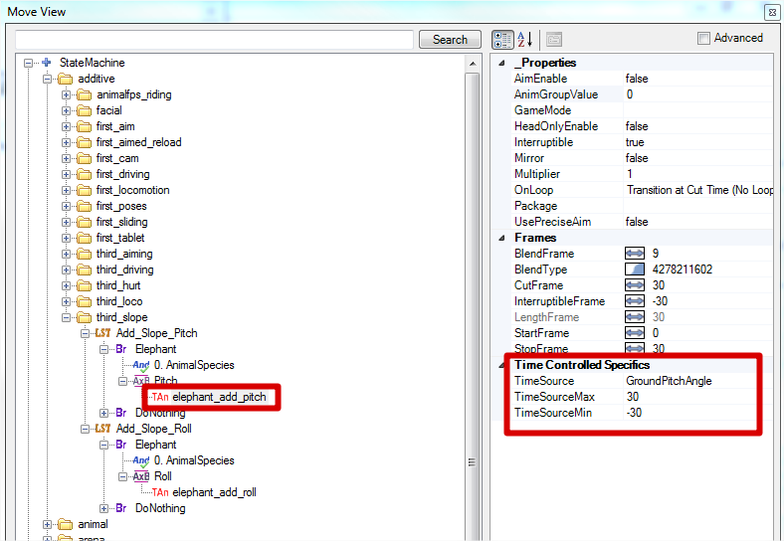

Find the **Add_Slope_Roll**move and add a time-controlled animation as ADDITIVE. Set the following:

* **TimeSource     GroundRollAngle**
* **TimeSourceMax     30**
* **TimeSourceMin    -30**

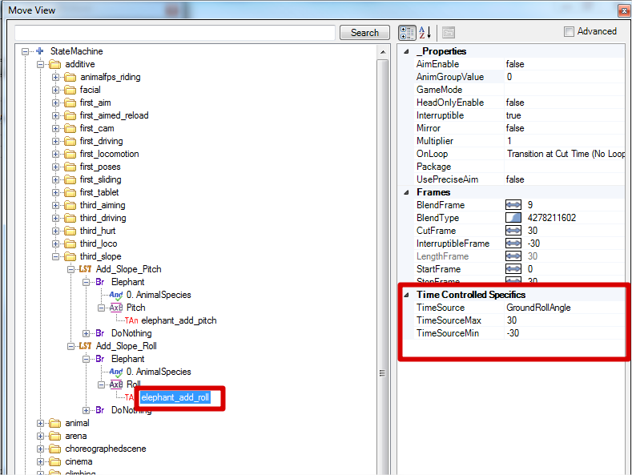

**Applying the Additives**

For the states or branches you’d like the additive animations applied, create a **Layered State Insertion**and the additive will get applied**over the top of everything** within the branch.

**Note:** This process may change depending on feedback from AI programming.

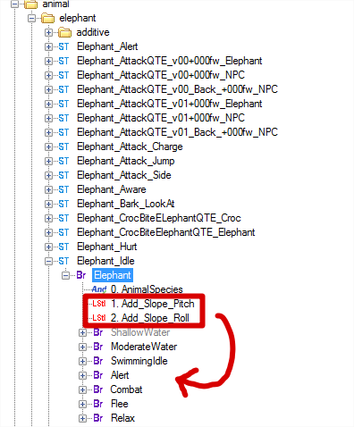

**Human IK Tuning Parameters**

**Entity Smoothing**

* **Upward Max Speed:**maximum speed that smoothing is applied
* **Updwad Z Min:**  the minimum smoothing is applied at the maximum speed
* **Upward Z Max:**  the maximum is applied when the speed is near 0

**Debugging in Dunia**

Show Difference Between Animation and IK Reach – QuadrupendIK Ground Follow Debug View

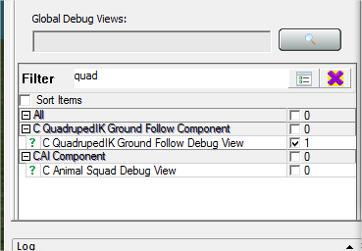

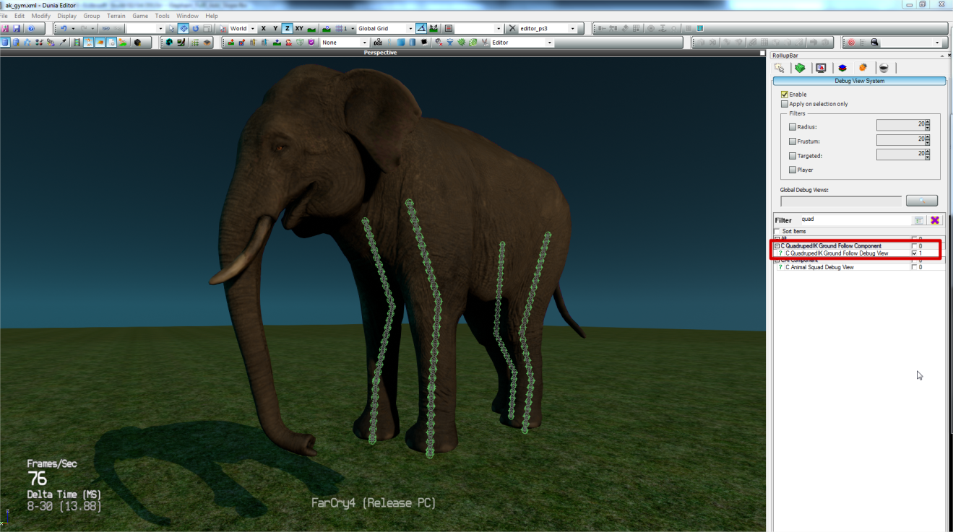

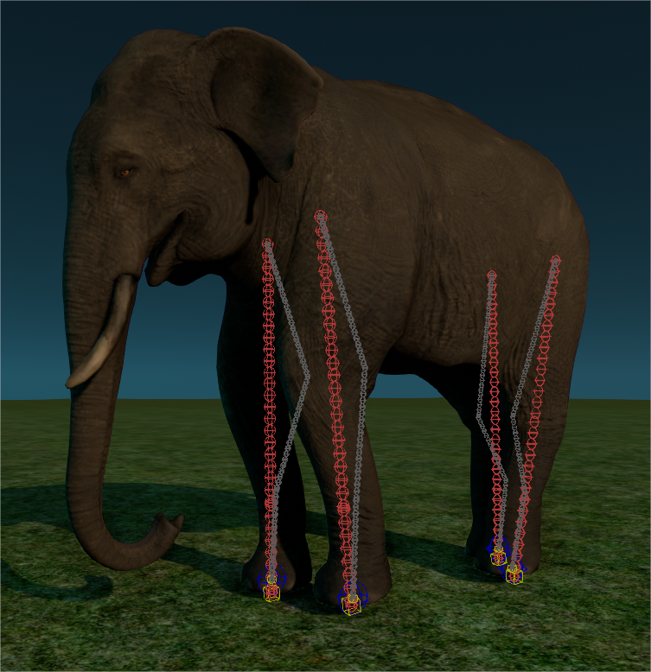

Note: when the bones turn red, they are hyper-extended.

**hik_enable_debugdraw_effdata = 1**      Shows IK foot effectors

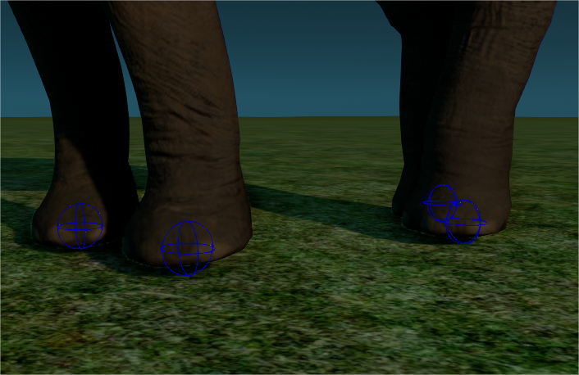

**hik_tune_force_effector_range 1**     Used to tune min/max range values for each limb  
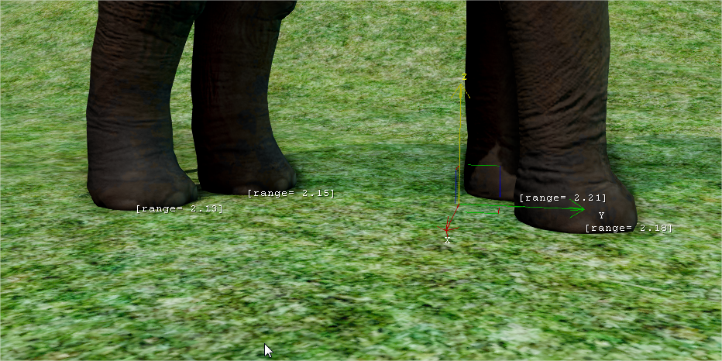  
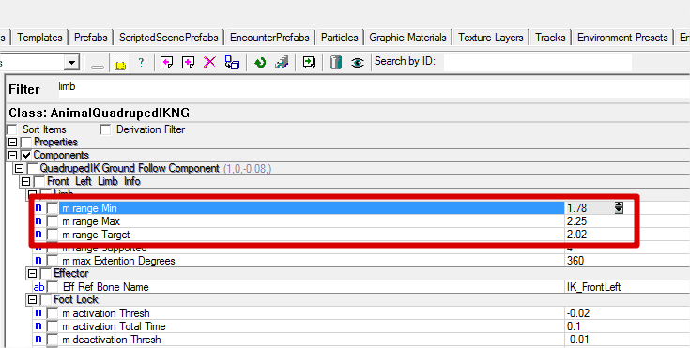

**hik_enable_debugdraw_groundangles 1**  Show computed ground normal for pitch and roll

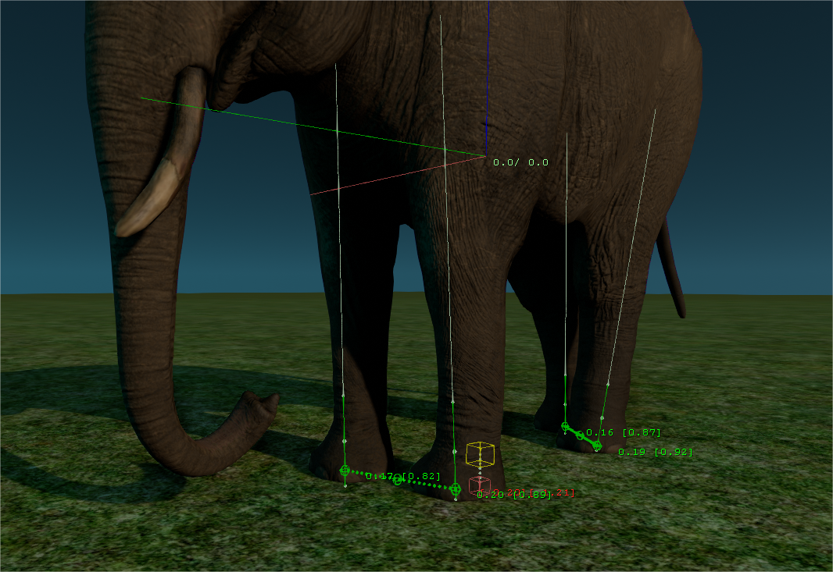

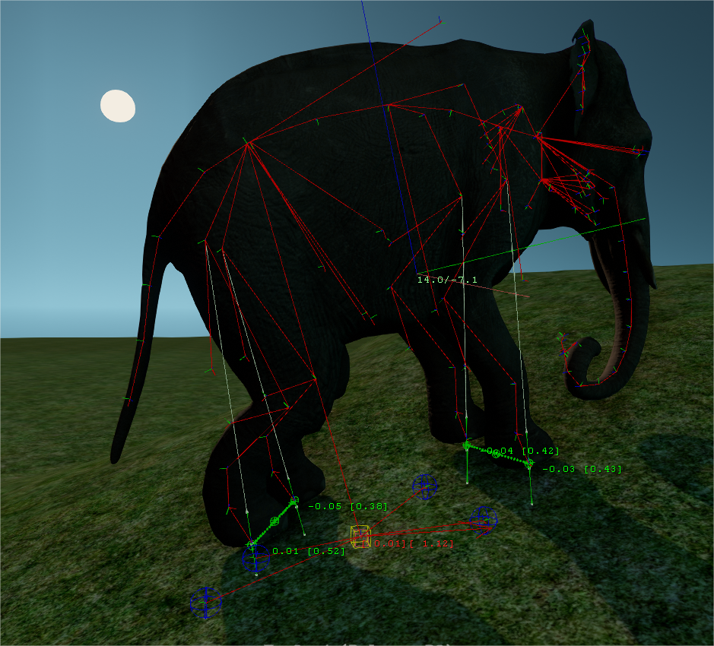

**dv_animation 1**           Enable animation skeleton debugging commands

**anim_display_animskeleton 1**    Display animation skeleton

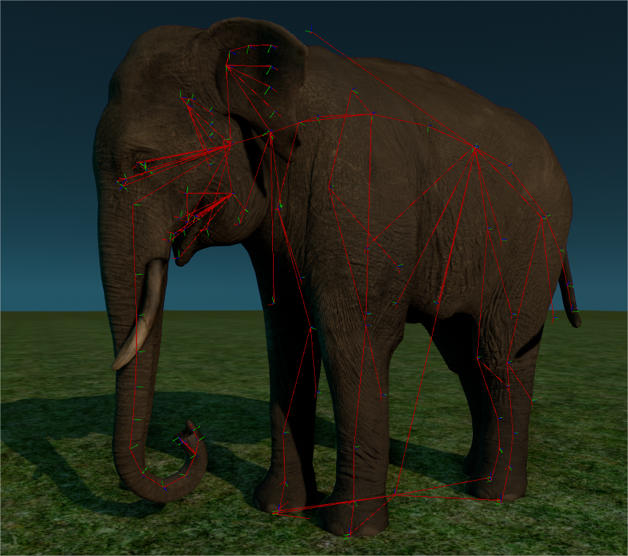

**animskeleton_display_names 1**       Display bone names

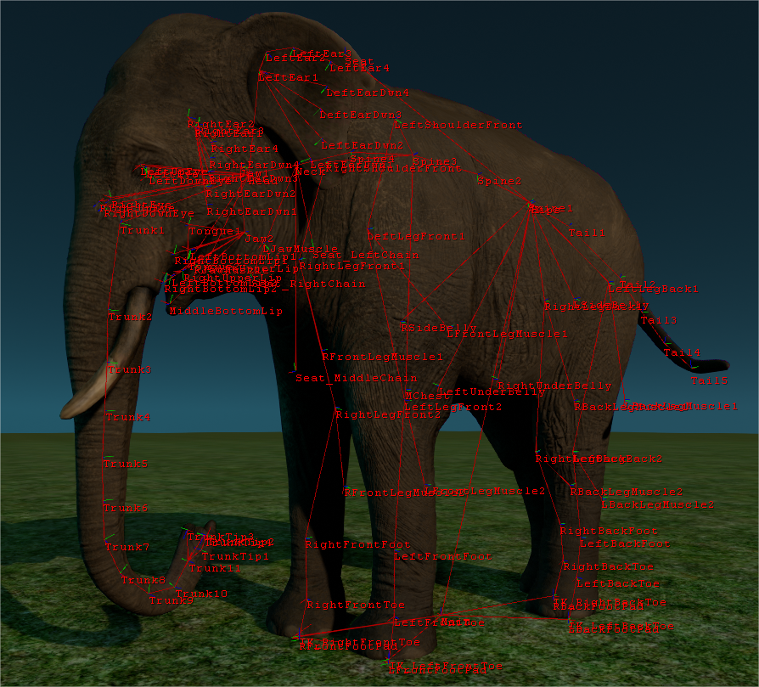

**anim_display_hikskeleton 1**   Show HumanIK skeleton

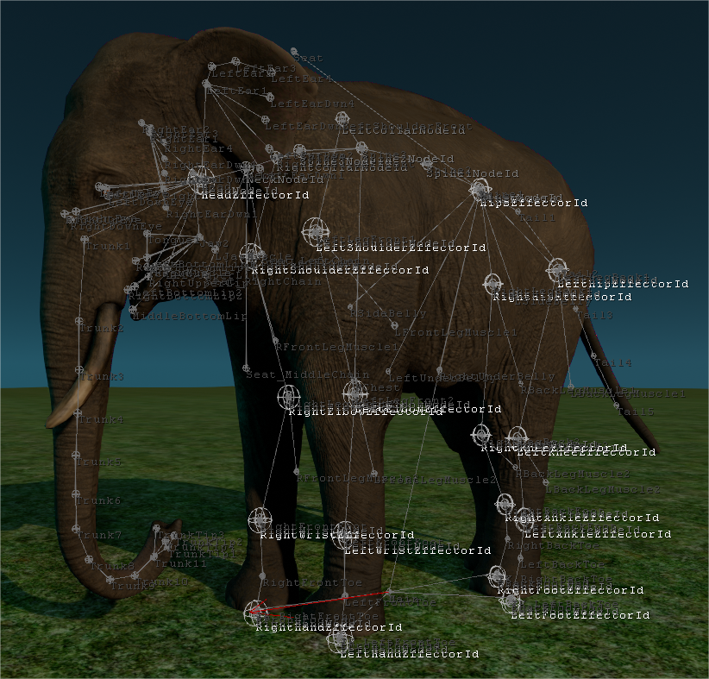

**Editor tuning console commands:**

hik_tune_floatingentity_effdata

hik_tune_effector_ranges

**System (turn off humanik or part of humanik)**

hik_disable_humanik_effectors

hik_disable_humanik

**Debug draw commands:**

hik_debugdraw_state

hik_debugdraw_groundfollow

hik_debugdraw_effdata

**Pitch/roll manipulations:**

hik_pitch_simulate

hik_roll_simulate

hik_pitch_fix

hik_roll_fix

hik_disable_pitch

hik_disable_roll

**Debugging Additives in the Move States Viewer**

The additives can be tested in the Move States Viewer layered on top of any animation state.

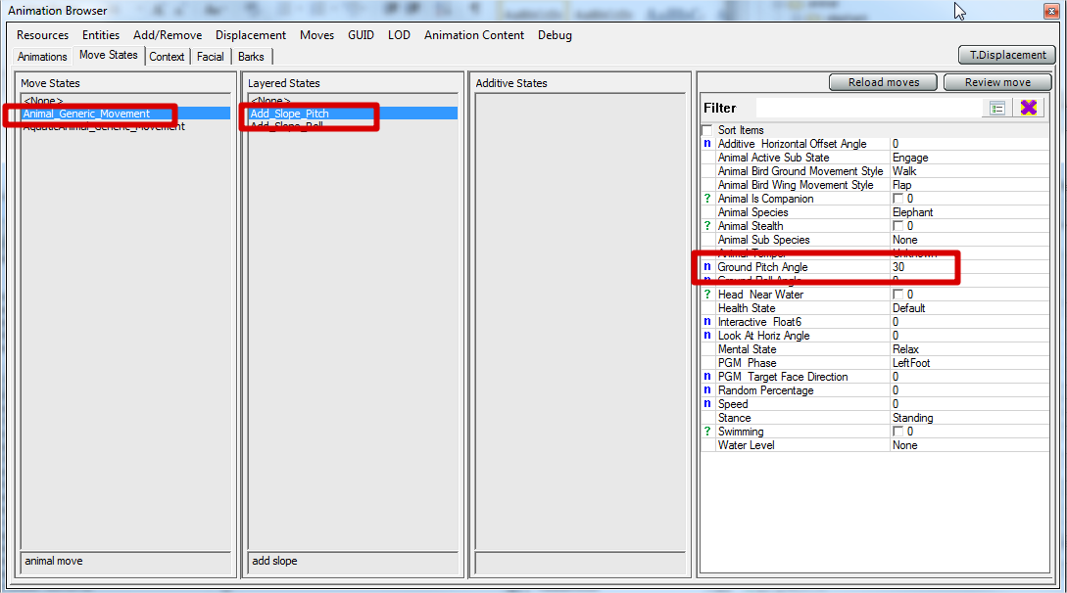

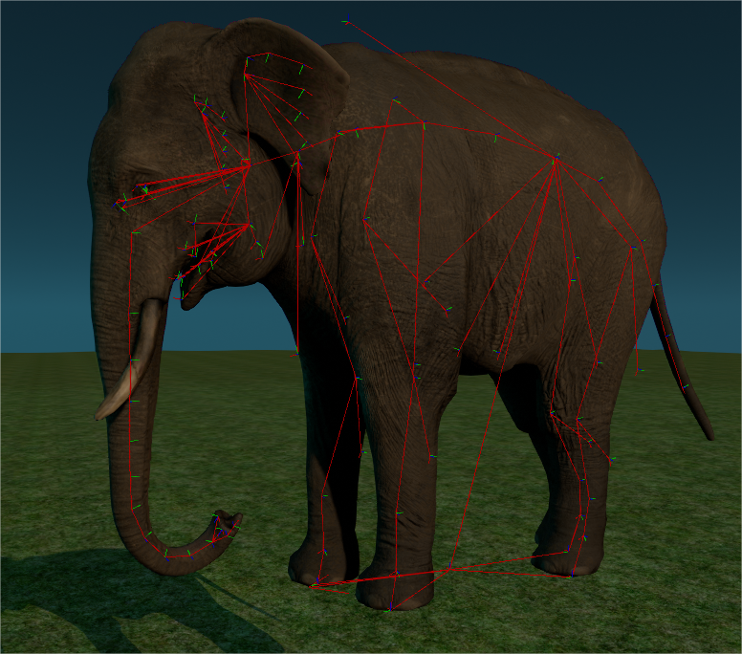

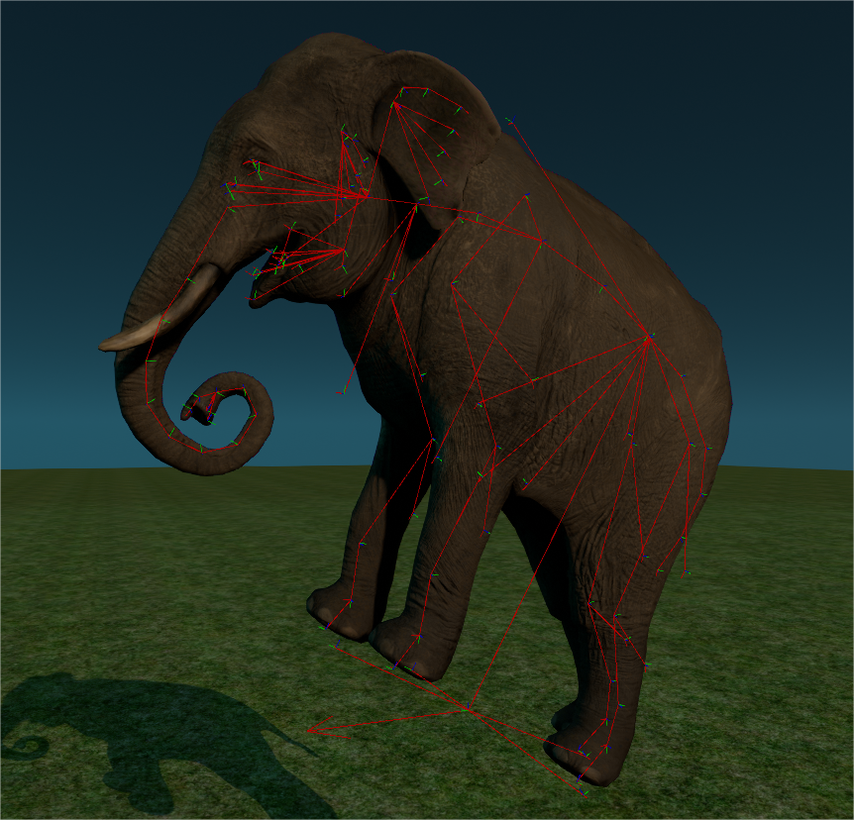

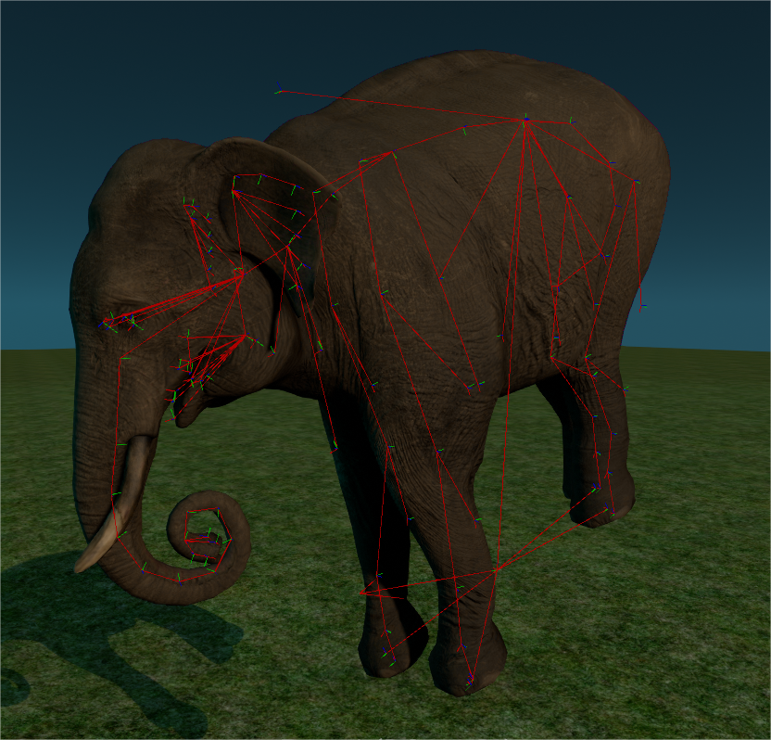

**Misc Info**

**Comparison**

Additive + IK Solution (FC4) vs. Ground Normal Alignment (FC3)

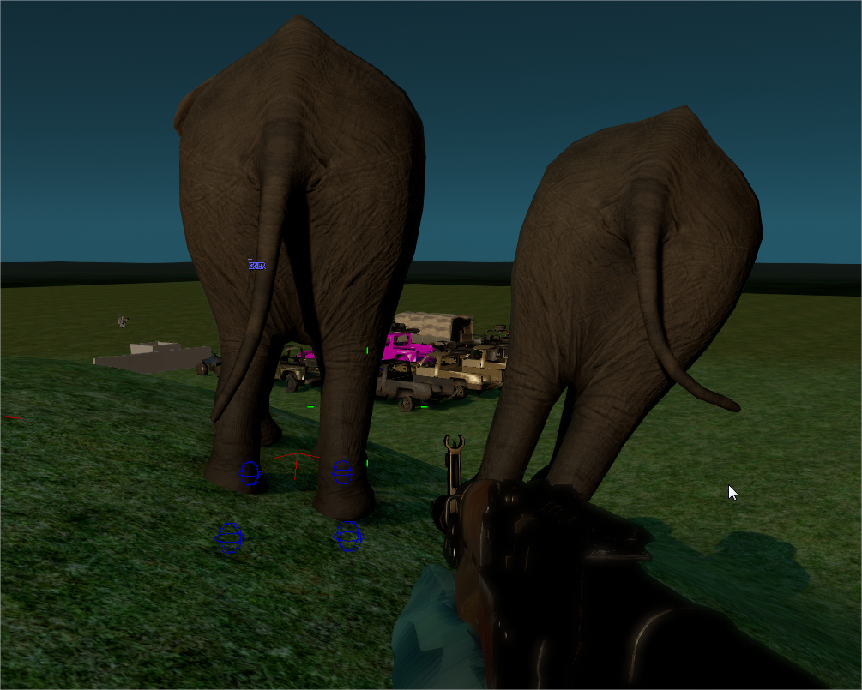

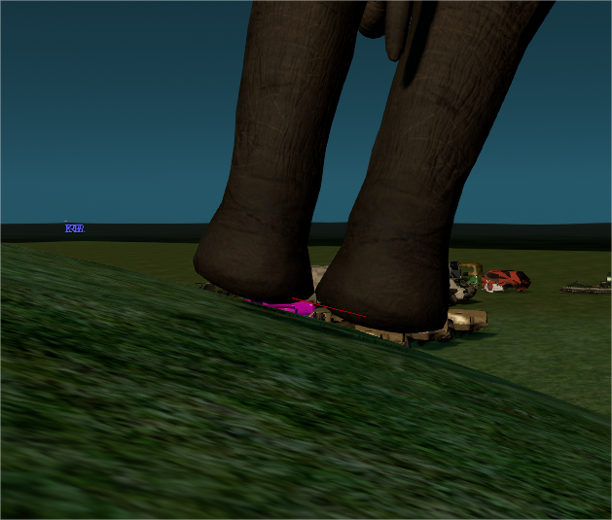

**Additional Bone Cost**

**Before Additional Bones**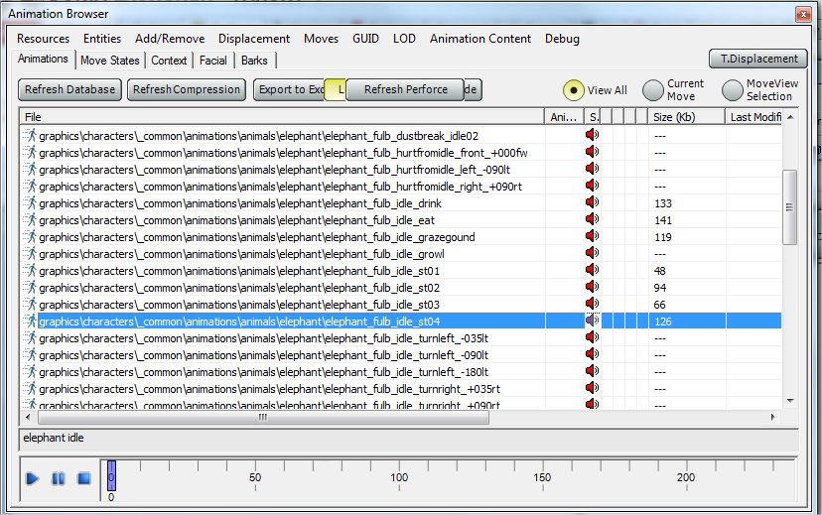

**After Additional Bones (size dropped in some cases?)**

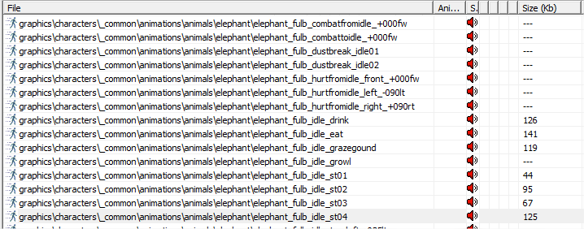

**Elephant Before Rig Changes (PS3):**1,803 kb

**Elephant After Rig Changes (PS3):**1,905 kb

**Production Cost**

**Update all Elephant animations – 8 hours**